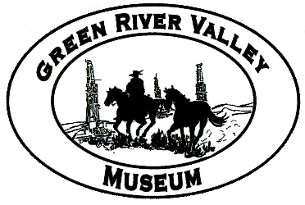
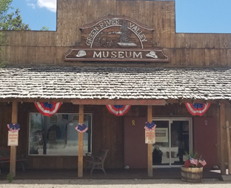

GREEN RIVER VALLEY MUSEUM
APRIL 2023
206 N. Front St, Big Piney WY
Open June-October. Admission Free.

LETTER TO THE COMMUNITY
By Clarica Johnson, Director

Last year was a success! We increased the number of visitors to the museum by 149 having over 1,585 people. We had visitors from Montana, Michigan, Florida, Minnesota, Vermont, France and Spain. All of them were amazed that a small town could have such a big museum. This is thanks to all the great people of Sublette County. It is my pleasure to show off your treasures to people from all over the United States. Our museum really paints a picture of what it was like to live in the wild west. We also had several field trips of students from Pinedale and Big Piney; it is so great to have these young children interested in our history. Every year, we have had an increase of memberships to our museum and I would like to thank you for your support. We couldn’t do it without you!

WHAT’S NEW:
We’ve received a grant from the Wyoming Community Foundation! It’s a challenge grant worth $11,500, and thanks to the success of Hardhats & Stetsons last month, we’re eligible to receive the full sum. Hardhats & Stetsons 2023 was a triumphant return to our long-standing community event, and after four years of waiting we were thrilled to discover that it was our most successful fundraiser ever. We also attended the Pinedale Half-Marathon last fall, which was another great day of community involvement. The grant and the funds raised from these events are going toward the Texaco Project.
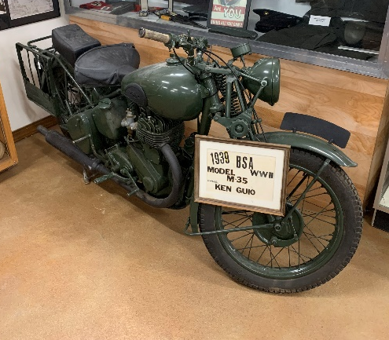
NEW ADDITIONS:
- Mounted moose that was shot by Steven Fisher in Middle Piney in 1985
- Big Piney High School senior photos from Deena and Ross Copeland
- Wenz family arrowhead collection with frames made by Dick Tanner
- V-mail letters and envelopes from World War Two
- Original Texaco gas pump globe
- 1965 Bombardier Ski-doo (courtesy of Tagg Guio)
- 1939 WWII motorcycle belonging to Ken Guio (courtesy of Tagg Guio)
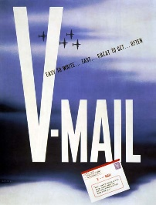
MAIL CALL!
By Buck Bell, Assistant Director

One of our new exhibits is all about Victory Mail. “V-mail” was introduced during WWII to economize communication between American troops around the globe and their families back home. A soldier would write their letter on a full-sized page which would then be photographed onto microfilm. Since these film negatives were lighter and easier to pack than real letters, huge numbers of them could be transported at a fraction of the cost. When the negatives arrived in the U.S., they were developed, issued to the Postal Service, and delivered to families from coast to coast. This new method of condensed communication enabled enlisted individuals to contact their loved ones when it otherwise might not have been possible to do so (this process was also very secure: censors had multiple stages to review the content of the letters and invisible ink couldn’t be read through the film). World War II was such a massive event that details like V-mail can seem unimportant, but when you take a closer look you realize that each message transmitted through this service was the story of the war in miniature - the story of people separated from their families and shouldered with an immense responsibility. When it comes to studying history, sometimes you can see more through a peephole than you can through a window. Our V-mail exhibit can be found in the Veterans Area in the Back Building. It includes both the original messages and transcriptions for easier reading.

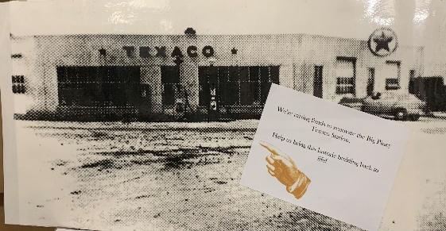
COMING SOON:
Our project to rebuild the Big Piney Texaco Station is well underway. With the funds we’ve raised so far, we hope to take steps to restore the building’s structural integrity so that we can begin making use of the space. The building will house new exhibits (opening up much-needed space in the museum’s existing buildings) and a new South Sublette County Visitors Center. With the help of Kenna Tanner’s donation and Bartie Bray’s expertise, we are working to restore our Texaco gas pump to its former bright-red glory and install it in its rightful place in front of the building. Should be eye-catching!

ACKNOWLEDGEMENTS
- Special thanks to the Sublette County Commissioners and the Sublette County Museum Board for their support of the Green River Valley Museum, and to our board members, past and present.
- Thank you to Kenna Tanner for donating a real Texaco gas pump, and to Bartie Bray for starting to restore it!
- Thank you to Linda Tanner for her generous donation through the Helen Tanner Memorial Trust.
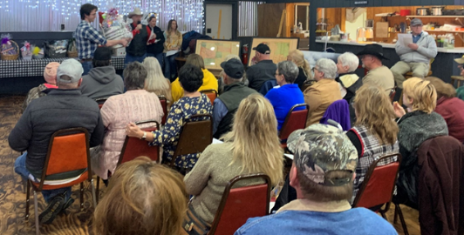
- Thank you to the Wyoming Community Foundation for providing us with the grant.
- Thanks to everyone who participated in Hardhats & Stetsons and made it such a success!
- Thanks to Jonita Sommers for her donation to our Texaco Project!

MEMBERSHIPS AND MEMORIALS:

Guarantors
Cora Vista Ranch/Marina Abrams
James F. & Mae E. Mickelson Estate
Jonita Sommers
Benefactors
George Kahrl
Surveyor Scherbel, Ltd.
Patrons
Bill & Susie Lehr
Bill Murdock
Bob Harrower
Bonnie Budd
Dale Hill
Dave & Lisa Doorn
David & Mary Burnett
Dawn Ballou
Dick & Georgia Wenz
Frank & Nancy Sansone
Glenna Johnson
Jared & Chandra Holgate
John & Sylvia Harber
Jon & Sheryl Boroff
Joyce Browder
Ken Fear Jr.
Linda Tanner
Liz McKinsey Dailey
Madeleine S. Murdock
Martin Wardell & Son
Mary Lynn Worl
Max & Dianne Boroff
Mel & Sue Kinikin
Milford & Jeannie Lockwood
Pam Chrisman
Pearson Livestock, LLC.
Pinedale Online!
Richard Kalber
Rocky Mountain Pwr Sports, Pinedale
Stan & Cara Olson
Steele Ranch Beef
Sublette Co. Artist’s Guild
Sublette Insurance/Windy Noble
Tagg & Nancy Guio
The Stepp Family
Tim & Jody Thompson
Walker’s Agri-Service, Inc.
Warren E. Sorenson
Zachary & Cori Wenz
Sponsors
Chad & Gudrid Espenscheid
Deena Martin
Dennis & Kay Lynn Mahaffey
Jack & Helen Hegardt
Jamie Wood
Jim & Fran Robinson
Jim & Laurie Latta
John & Belinda Emerson
Larry & Kathryn Mizell
Linda Sternberg
Lori Reiland & Glenn Eiden
Maggie Miller
Mary Anne Almquist
Mary Borgeson
Michael G. Hawkins
Mickey & Becky Hicks
Mike McKinsey
Mike Vargo Jr.
Paul & Tina Rock
Richard & Sharon Costello
Ron & Dianne Davison
Tara Miller
Members
Barbara Anderson
Carol Grimes
Carson & Nan Stinson
Cris Paravicini
Dave & Mary Lankford
Duane Calvert
Gordon & Cheri Johnson
Greg & Amy Bell
JoAn Neumayer
Keith & Talli Manning
Ken & Arlinda McLaughlin
Ken & Karen Taylor
Linda Gray
Lisa Parra
Margy Hawley
Mark & Marianne Mrak
Mark Ruark & Julia Van de Ven
Mike & Jeanette Cooney
Phillip Carr
Robert Phillips
Ron & Theresa Hager
Skylar Wilson
Tawny Roberts
Memorials
John Tanner
- Betty Fear
- Carrie Anderson
- Pat & Marilyn Herring

GREEN RIVER VALLEY MUSEUM BOX 12 BIG PINEY, WY 83113
Please circle type of membership
Member ($25) Sponsor ($50) Patron ($100) Benefactor ($500) Guarantor ($1000)
Name _________________________________
Address _______________________________
City ___________________________________
State _________________________________

BOX HOLDER
BIG PINEY WY, 83113
EDDM
RETAIL
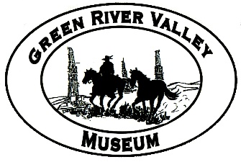
GREEN RIVER VALLEY MUSEUM
PO BOX 12
BIG PINEY WY, 83113
Come visit us!
We invite you and your family or civic group to visit the museum this summer. If you would like to schedule a tour, please call us at 307-276-5343 or send an email to director@grvm.com. For your convenience you can now become a member or create a memorial on our website, grvm.com. Find us on Facebook, Instagram, and Twitter!
Hours:
Mid-June – Mid-October
Tuesday – Saturday
11-5
Admission by donation

206 N. Front Street
PO Box 12
Big Piney, WY 83113
307-276-5343
Board Members
President
Toni David
Secretary
Sherri Bohleen
Treasurer
Jeannie Lockwood

Pam Chrisman
Becky Downs
Deena Martin
Haley Clark
Tracy Hughes

grvm.com
director@grvm.com

Director
Clarica Johnson
Assistant Director
Buck Bell
Bookkeeper
Karen Taylor
Summer Staff
Abigail Pinkerton & Lena Hatch

